Case Study for IT Graduation Project

Şeyma Kaçar

Cihan Ünal

Sermet Eser Özvataf

Abstract
This work determines the Graduation Project Preparation and Graduation Project courses in EMU. The paper explains the current situation, problems, requirements and solutions of graduation project courses.

Keywords: IT Graduation Project, Case Study

Table of Contents

Abstract 2
Table of Contents 3
Introduction 5
Environment 5
Goals 5
Defined Problems 5
Provided Solutions 6
Overview of ITEC401 7
Assignment of Team Members 7
Graduation Project Groups (Advisor, Communication, Culture, Roles and Report) 7
Evaluation of Team Members 8
Overview of ITEC402 8
Reassembling Project Team Members 8
Evaluation of the Students 8
How Development Process Works 9
Submission of the Project (The Report and Source Codes) 9
Project Presentation 9
Possible Problems Defined 9
Project Management Ambiguity 9
Dynamic Responses to Changes 9
Dependency to Individuals 10
Lack of Project Methodology 10
Communication 10
Competition 11
Lack of Versioning and Issue Management 11
Portability for Online Continuation 11
Testing 12
Solutions Suggested for Problems 12
Strict Definition of Roles 12
Crowded Teams and Atomic Assignments 12
Following Project Management Disciplines 13
Using SCRUM 13
Issue Management Software 13
Version Management 15
Continuous Integration 17
Online Communication Platform 18
Patenting Against Stealing 18
References 19
Figure Captions 20

Introduction

Introduction
This paper analyzes how graduation project is delivered for IT students of School of Computing Technology in Eastern Mediterranean University. By defining some deficiencies of current course plan, alternative methods will be given in the text.

These alternative methods are compiled from the best practices which are being applied by the software companies in private sector.

Environment
The courses are given at the last two semesters of Information Technology program of School of Computing Technology, Eastern Mediterranean University which is a 4 year education that academically graduated as Bachelor of Science. In their words, the school’s primary goal is to prepare highly skilled technical human resources demanded by the business, industry and service sectors of today's globalized digital world.

School of Computing Technology (SCT) possesses ASIIN and EDEXCEL accreditations. So far 5939 students graduated from SCT and 847 students are still continuing their education.

The graduation project covers 2 semesters in schedule. The first part of the graduation project is a course named Graduation Project Preparation. In this course, some paperwork is expected from students in order to publish a plan for given project. And the second part is the Graduation Project course which is the period for development, implementation and presentation.

Goals
This paper will offer some practical modifications on the courses. The ideas offered are constructed in the aspects of project management. These aspects are mainly management, effectiveness, consuming the resources efficiently, etc.

Defined Problems
- Project Management Ambiguity
- Dynamic Responses to Changes
- Dependency to Individuals
- Lack of Project Methodology
- Communication
- Competition
- Lack of Versioning and Issue Management
- Portability for Online Continuation
- Testing

Provided Solutions
- Strict Definition of Roles
- Crowded Teams and Atomic Assignments
- Following Project Management Disciplines
- Using SCRUM
- Issue Management Software
- Version Management
- Continuous Integration
- Online Communication Platform
- Patenting Against Stealing

Overview of ITEC401

Assignment of Team Members
Every semester, seven instructors are assigned to seven different project group and students who want to take graduation project from a specific instructor can select that group as well. In that time, students can choose their both group members and teachers fairly.

According to the timetable of the lecture, students and instructors come together to announce the final situation of the assigning students to projects, and students are also informed about the processes of the graduation project course in the first class hour.

In the following weeks, this process is followed by presentations (workshops of instructors) which are predefinitions (database, programming languages, security, system development tools and etc.) for groups to develop their systems in the schedule with high quality. To be sure that everybody attempts to the presentations, attendance is mandatory and it also has percentage on the grading policy. After each presentation, slides are uploaded to the web site of the course for students to study them later on, because there is a final exam that includes all these presentation at the end of the semester.

After the first week of the class, group members start to go to the presentations as well as making their weekly meetings with their instructors. In this meeting, roles are assigned to project members according to their technical knowledge and skills.

Graduation Project Groups (Advisor, Communication, Culture, Roles and Report)
Advisor’s hands on the project provide us to control both learners and the project itself. Students and their teacher usually choose a day and time (15-30 min. per a week) to make their weekly meeting, so; they can discuss the requirements and process of the project in that time. As it is mentioned above, weekly meetings are made in a defined time but learners generally prefer to use social media web sites such as facebook. Assigning of the jobs is normally done between group members or by teacher.

Another important point is that there are many learners from all around the world and they also have their own cultures. These cultural differences also bring some difficulties. For instance, religious holidays can be at different day and time, so; these days are scheduled also.

The report which includes the diagrams (Gantt chart, use-cases, activity, ERD, user interface prototypes and etc.) is prepared by students to be delivered at the end of the semester and the template of the report is also available on the course website. After report is delivered, students take a final exam about this course and the exam is held on a determined day in the final exam period.

Evaluation of Team Members
Firstly, students are evaluated by their own instructors according to their performance and attendance. Following this, their report is graded and students are responsible to take the final exam of this course.

Figure 1. Evaluation system.

Overview of ITEC402

Reassembling Project Team Members
Normally, students take this course after they took ITEC401 because, they start to develop application part of the project by using the diagrams what they produced one semester before, and; they need to draw some new diagrams and they need to prepare a new report which has all of the diagram, description of the project and test results of the application. Students are also responsible to prepare a user guide for their project. Finally, they are ready to submit their projects and present their final products.

Evaluation of the Students
Firstly, students are evaluated by their own project instructors. Following this, they are evaluated by jury members during the presentation and of course both their reports and codes are graded as well.

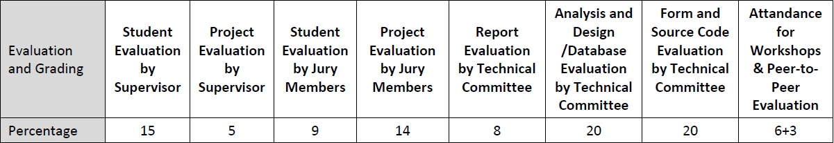
Figure 2. Students Evaluation system.

How Development Process Works
Weekly meetings are continued by learners and instructors, because; instructors need to see every steps of the developing system. Also, there is a class hour for students to show their works to both teachers and other students (other groups).

Submission of the Project (The Report and Source Codes)
At the end of the semester, a specific day is announced for students to submit their works or students bring their project in the presentation day to submit them. Also, the project consists of report, user guide and source codes.

Project Presentation
In the presentation, project team members present their products, and; after the presentation, they submit their final product and they leave the presentation room. Following this, Jury members evaluate students’ performances immediately.

Possible Problems Defined

Project Management Ambiguity
Since it is the first long-term project experience for most of students, team members tend to accept their advisors as project managers. This problem occurs in a very natural way in result of dynamically built relationships between people.

Where project management role and the other roles of members are not strictly defined, resource and time management issues become unescapable.

Dynamic Responses to Changes
Apart from role ambiguity full-time project management is also needed for estimation of whole progress, using resources and retain healthy communication between people involved.

Even in an optimistic scenario, the project members are students and their time availability depends on their assignment and exam schedule. Apart from that, national holidays and travels to home countries are also plays an essential role in time management especially in a multinational environment.

Team members’ poor task handling, guesses on time estimation for their tasks, technical problems occurred also critical issues for a group assembled of people not knowing their capabilities and professional behavior very well.

Dependency to Individuals
Instead of breaking down the work in smaller parts, people with no experience in project development tend to assign whole responsibility of a component to a specific assignee which is seems experienced on this part.

This approach usually reduces communication and makes estimation difficult and person-centric. During lack or unproductivity of a resource, all development of related section stops. That means project is not benefit from teamwork and not using its resources properly.

One special case because of the nature of course, ITEC403 students may not take ITEC404 if they have some problems. In this kind of situations, there is no option left but reassignment of tasks.

Sometimes leaving of people unpredicted and that means all work a person did up to that point gone with himself/herself. For example, a backend developer left the project due to his/her family issues while possessing all the developed code in his/her hard-drive.

Lack of Project Methodology
Courses itself give students a roadmap with submission dates. Because of that, ITEC403 students start planning on Gantt charts, then diagrams. It is very similar to traditional project management models since its “all planning done first” approach.

When ITEC404 begins, implementation of project brings some scope changes because of time and resource management. Even middle of semester there can be such changes and miscalculations. In such environment that many IT projects fail under the hood of large companies, it is very natural. But it drives adopting agile methodologies unwittingly.

Letting project conditions control the team is not a healthy scenario because of obscurity. It makes all kind of planning and estimation impossible. For this reason, project team must determine their project management methodology first.

Communication
Due to communication among team members depends on team meetings, meetings medium change and teams need to find out their proper way to communicate.

A basic need of this communication is keeping in touch with team members. But this may be difficult when someone’s absence or inaccessibility. And blaming team members is not the way of overcoming this kind of communication problems.

Especially meetings with advisor are restricted into working hours and scheduling meetings gets impossible in crowded groups.

Also meeting notes, history for decisions and this kind of written materials memorized by people not to get forgotten, but eventually people forget and keeping track of discussed issues no longer possible.

Competition
Single topic of graduation project stated for all groups. That means all groups in a competition and claims best-project award.

In a university environment all students expected to be colleagues who work for science. Provided knowledge and experiences of all academic works done are transferred to the next level and their outcomes are share with academia. And a competition environment serves vice versa.

Project teams tend to keep their methodologies on how they solved the problems and their approaches in secret. This also makes Knowledge Management impossible since people do not encourage sharing the discovery they done.

Lack of Versioning and Issue Management
The linear progress of development cannot be watched neither of project manager or advisor. This makes situation person-centric again where the observation of third party is not possible.

Also, in the scenarios the tester is a different role; it is not possible to always testing latest edition and testing against latest breaking changes. Even it is acceptable, there is no way to know and specify the issue fixed or not and, when it started to occur exactly since modifications has not revision numbers.

Portability for Online Continuation
While private sector migrating all IT-work and leading universities serves their course contents location-independent with the advancement in cloud computing, ITEC401 and ITEC402 still needs group meetings arranged when it is free for everyone.

Communication and file sharing is handled by methods that group members their preference.

Testing
In software engineering discipline testing is a very important aspect. There are some quantitative metrics like code coverage to find out how many lines of code covered by unit-testing to prove it is correctness against regressions.

Assuming quality is also important for an IT project besides its usefulness and capabilities. Testing also needs to be expected from project groups.

Solutions Suggested for Problems
This section suggests some ideas in order to solve problems stated above.

Strict Definition of Roles
From the beginning of first meeting, every team member’s skills and capabilities should be known and listed in order to best allocation of resources. People who believe that he/she is good at management, also candidates themselves as project manager by declaring his/her approach and methodologies going to be adopted. A small election can be made among team members if there are many project manager candidates.

This suggestion is made in order to solve Project Management Ambiguity.

Crowded Teams and Atomic Assignments
Handling single responsibility is harder since it requires continuous concentration and existence. Dependency on single person for particular area makes him/his irreplaceable. All work power, knowledge and experience sticks with persons’ himself/herself.

Extreme Programming offers the idea of pair programming to keep team members concentrated and work together.

In the same way, most of agile methods adopted small amounts of work which comprised by the project is being incrementally developing. Because even one solid parts of the project can be broken down into phases to iterate the project to the next step.

By combining these two approaches, using crowded teams with smaller task items is considerable assuming they will be more resourceful. For example, two backend developer balances the total backend development workload on the project in long-term. And to use all resources simultaneously chunked work pieces of same task can be assigned to both.

This suggestion is made in order to solve Dependency to Individuals.

Following Project Management Disciplines
Adopting project management disciplines powers use of all resources efficiently in order to plan, organize, motivate and control through specific goals.

Since each project management approaches differs, sharing specific details impossible. But all of these approaches, as long as they are applicable, better than improvising because they have proven methodologies to achieve goals.

This suggestion is made in order to solve Project Management Ambiguity, Dynamic Responses to Changes, Dependency to Individuals, Lack of Project Methodology and Testing.

Using SCRUM
This suggestion is more specific revision of Following Project Management Disciplines. SCRUM is an incremental and iterative IT agile project management methodology, which is focuses on software development. By collecting requirements and rewriting them as backlogs which are stored in a same pool with others. These backlogs can be added/removed anytime during the development of project. When the implementation of the project begin, project manager picks some tasks from backlog by considering their importance level to create an iteration named sprint. A sprint follows another one until all backlogs are finished. Sprints also can be executed simultaneously.

Since sprints can be decided anytime, it provides dynamically focus on project’s needs occur during the development.

Also approximate time entered to backlog data get summarized to compare each sprints actual and predicted periods. Therefore more accurate estimations can be made after comparing the performance of few sprints done.
This suggestion is made in order to solve Dynamic Responses to Changes, Dependency to Individuals and Lack of Project Methodology.

Issue Management Software
Issue managers designed to manage and maintain list of issues. It helps project management during the implementation of development tasks especially. This software keep tracks of each task item and its history with some details such as assignee, description, importance and due date.

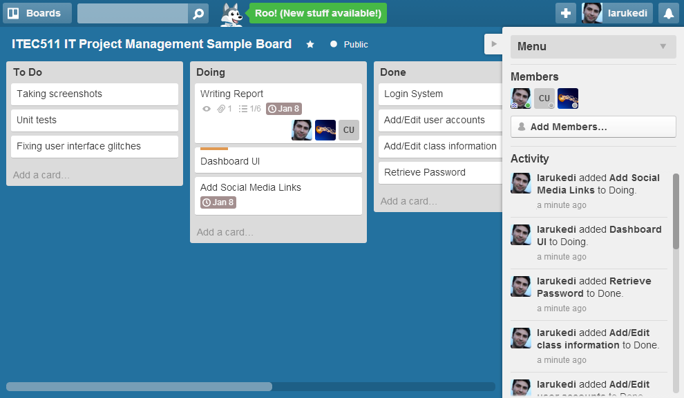
Figure 3. Trello Issue Management Software. Tasks View.
An issue management tool, Trello is used in figures. It can be visited on www.trello.com but there are many alternatives depending on requirements and usage.

Using such systems also is useful to track students’ attendance to projects for advisors and is also a great archive for the project, which can be later saved on knowledge management database of the organization.

This suggestion is made in order to solve Dependency to Individuals, Communication, Lack of Versioning and Issue Management and Portability for Online Continuation.

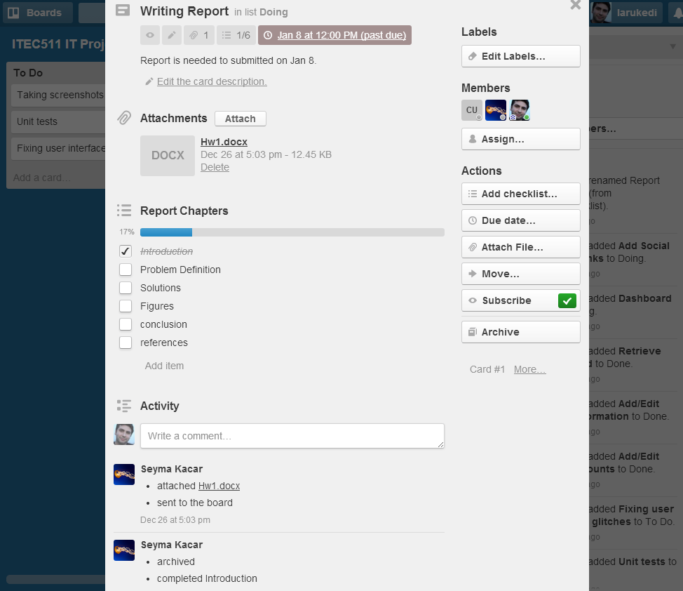
Figure 4. Trello Issue Management Software. Task Item View.

Version Management
Version management systems, also known as revision/source control systems, basically manage the changes of documents by enumerating each change. Any of these enumerated changes can be merged, copied or reverted whenever user wants.

Modern variations of version management systems allow user collaboration synchronously. It prevents users to overwrite someone else’s changes unwillingly.

These changes (named changeset) and latest version of documents stored a centralized storage named “repository” that allowed users can access to read and write.

Git is a widely known version control protocol, which is created by Linux’s creator Linus Torvalds. Github is modern software as a service which supports Git and hosts source repositories for free.

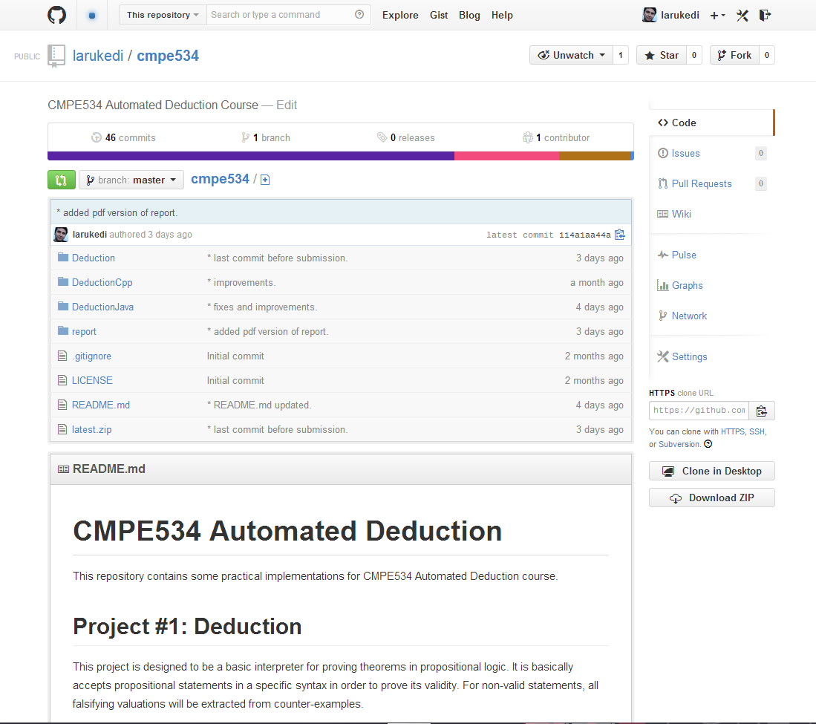
Figure 5. Version Control with Github.
Github also supports university students to host their projects and assignments “privately” in result of contacting them.

Advantage of using Github resolves an issue stated as dependency to individuals. Since all of assets and source codes are hosted on a public centralized repository, anyone with access can reach the latest and past versions of project. Therefore like in the issue management, every team member can aware of what is going on at the moment.

This suggestion is made in order to solve Dependency to Individuals, Communication, Lack of Versioning and Issue Management and Portability for Online Continuation.

Continuous Integration
Continuous Integration is a proposing of Extreme Programming. It is philosophically defined to provide healthy integration of each incremental change.

In modern software engineering, it constructs a composited model with version control to handle each change in order to check and provide its integration to designed system. Since its job description it is an essential part for testing and building.

A well-configured continuous integration system can test latest changes against regressions, does unit-tests, checks the code coverage, and; warns against new potential issues and code complexity. If latest change breaks stability of project or makes things worse most continuous integration tools warns developers with an e-mail.

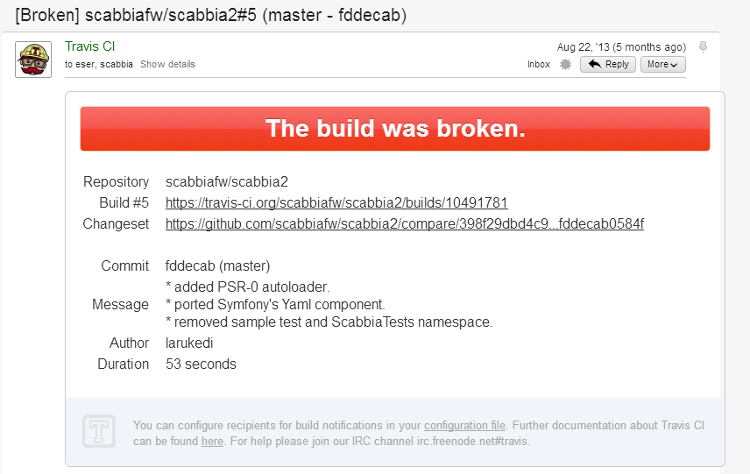
Figure 6. Travis-CI for Continuous Integration.

This suggestion is made in order to solve Lack of Versioning and Issue Management, Portability for Online Continuation and Testing.

Online Communication Platform
Online communication platforms can be various which allow participation of defined users. However any of them completely satisfies needs of graduation project team’s communication specifically, forums, mailing groups, news groups and facebook groups are perfect samples.

It would be better if a system built for especially to provide online communication for graduation project teams. In such environment, an interaction with the other project groups could made possible and materials like slides, workshop videos can be presented online.

This suggestion is made in order to solve Communication and Portability for Online Continuation.

Patenting Against Stealing
For stated problem in “competition”, project teams tend to hide their problem solutions. In case of establishment of online communication platform among project groups, approaches and solutions of specified problems can be shared with team signature in order to obtain the “parent” of solution.

Therefore published and offered solutions can be used or improved by other teams by referencing the original idea.

This suggestion is made in order to solve Competition.

References
SCT. (2009).Graduation Project Web Site from

http://sct.emu.edu.tr/courses/it/index.php?id=itec403&page_type=rich_text&element_id=3

SCT. (2009).Graduation Project Web Site from

http://sct.emu.edu.tr/courses/it/index.php?id=itec403&page_type=rich_text&element_id=4

Figure Captions
Figure 1. Evaluation system.
Figure 2. Students Evaluation system.
Figure 3. Trello Issue Management Software. Tasks View.

Figure 4. Trello Issue Management Software. Task Item View.

Figure 5. Version Control with Github.

Figure 6. Travis-CI for Continuous Integration.

